**Hope Foundations**

**FINOLEX ACADEMY OF MANAGEMENT AND TECHNOLOGY**

**Department of Electronics Engineering**

Mini-project- Details

|  |  |  |
| --- | --- | --- |
| **Subject: VLSI Design** |  | **Year: 2020-2021** |
| **Class: TE** |  | **SEM: VI** |

|  |  |  |
| --- | --- | --- |
| **Name of Advisor: Prof. Vrishali V. Nimbalkar** | | |
| **Project Title: 1 Bit ALU** | | |
| **Roll No.** | **Name of student** | **Sign** |
| **1** | **Bhave Omkar Vinay** | C:\Users\User\Downloads\IMG_20171230_101254 (2).jpg |
| **17** | **Sawant Parth Rajesh** |  |

**Abstract:**

At its most fundamental level, a computer consists of a control unit, an arithmetic logic unit (ALU), a memory unit, and input/output (I/O) controllers. The ALU performs simple addition, subtraction, multiplication, division, and logic operations, such as OR & AND.

We have designed the Adder using the CMOS logic, AND & XOR using Transmission gate logic and NOR using the Pass Transistor logic. The following chapters consider every part of the ALU (i.e. Adder, AND, NOR and XOR) gates with their respective logic. The last chapter is based on the final output obtained when the above circuitry is combined to for an ALU and the obtained result is correct.

**Simulation waveforms: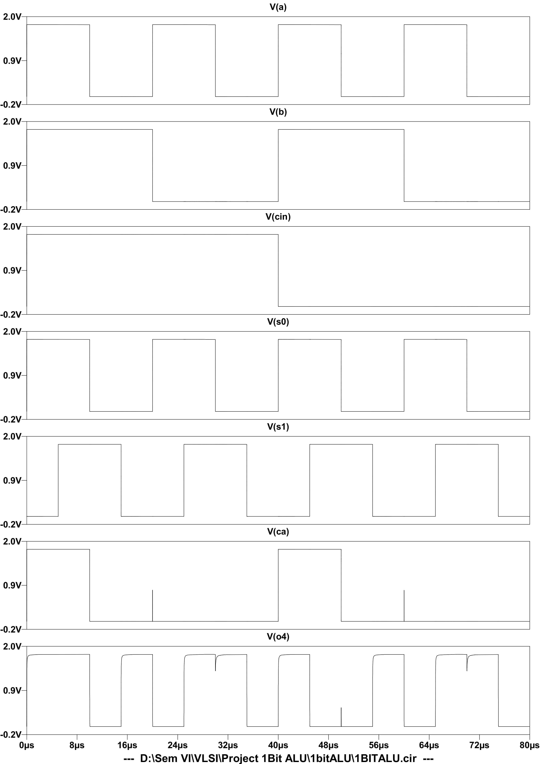**

**Evaluation Scheme for Mini-Project**:

|  |  |
| --- | --- |
| **Rubrics/ Name** | **1 Bit ALU** |
| Complexity (5) |  |
| Design verification(10) |  |
| Involvement in design of Hardware/Software(15) |  |
| Completion status(10) |  |
| **Total Marks:** |  |

**Signature of Project Advisor**

**Prof. Vrishali. V. Nimbalkar**